|  |  |
| --- | --- |
| 78490499 | https://journal.equinoxpub.com/CAM/issue/archive |
| 79387799 | https://journal.equinoxpub.com/POM/issue/archive |
| 290371499 | https://journal.equinoxpub.com/IR/issue/archive |
| 316397899 | <https://journal.equinoxpub.com/GL/issue/archive> |
| 318816399 | https://journal.equinoxpub.com/JSRNC/issue/archive |
| 318816499 | https://journal.equinoxpub.com/PENT/issue/archive |
| 322381499 | https://journal.equinoxpub.com/BSR/issue/archive |
| 322381599 | https://journal.equinoxpub.com/PB/issue/archive |
| 643108413 | https://journal.equinoxpub.com/QRE/issue/archive |
| 915617118 | https://journal.equinoxpub.com/EAP/issue/archive |

Above websites have the same structure of websites



**Select the Current issue from here.**

All required articles will be listed here.



**Page Range**

Meta data can be captured as below.

**Volume, issue**





**DOI**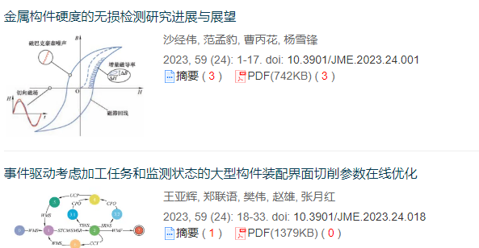

**Click here to download the pdf**

**Article Name**